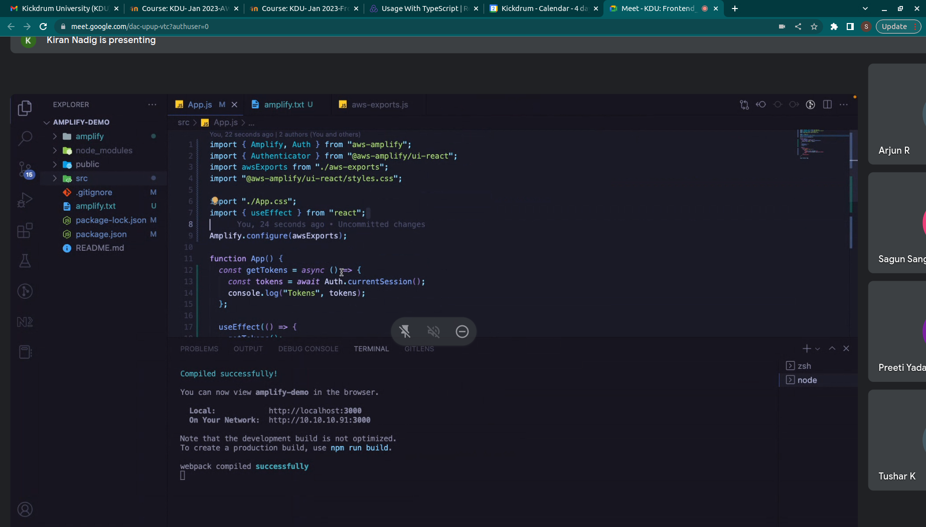
.

give

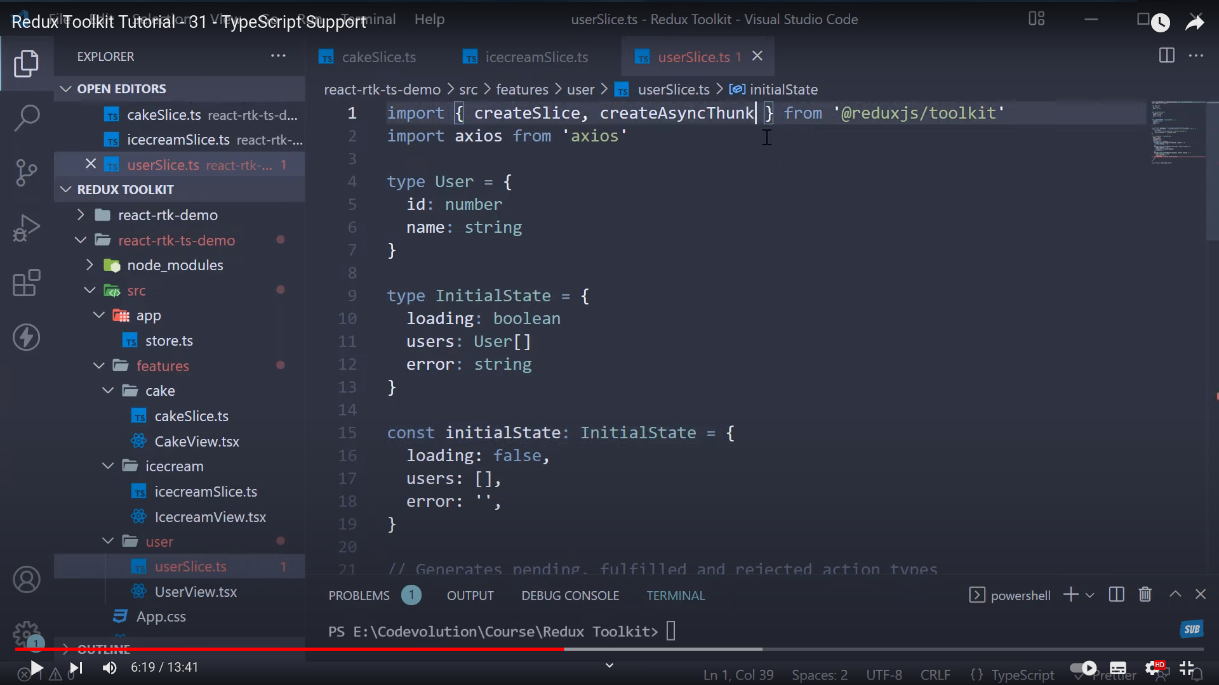
.
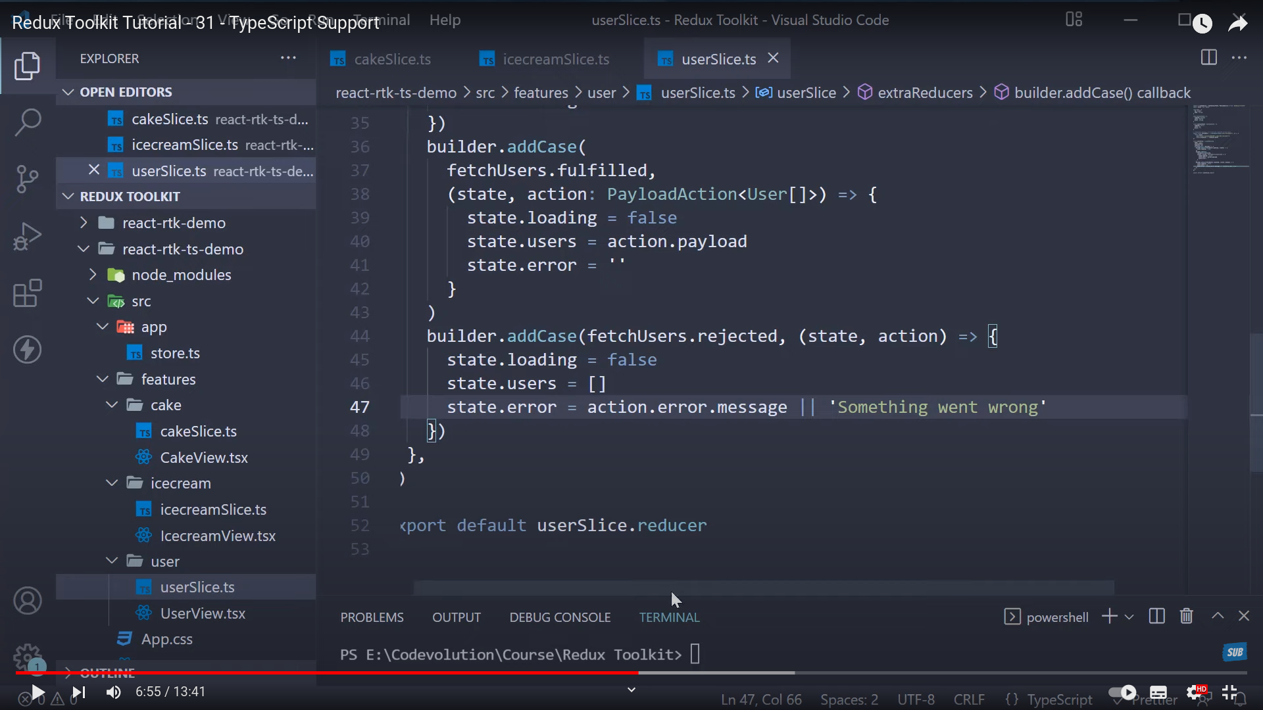
.

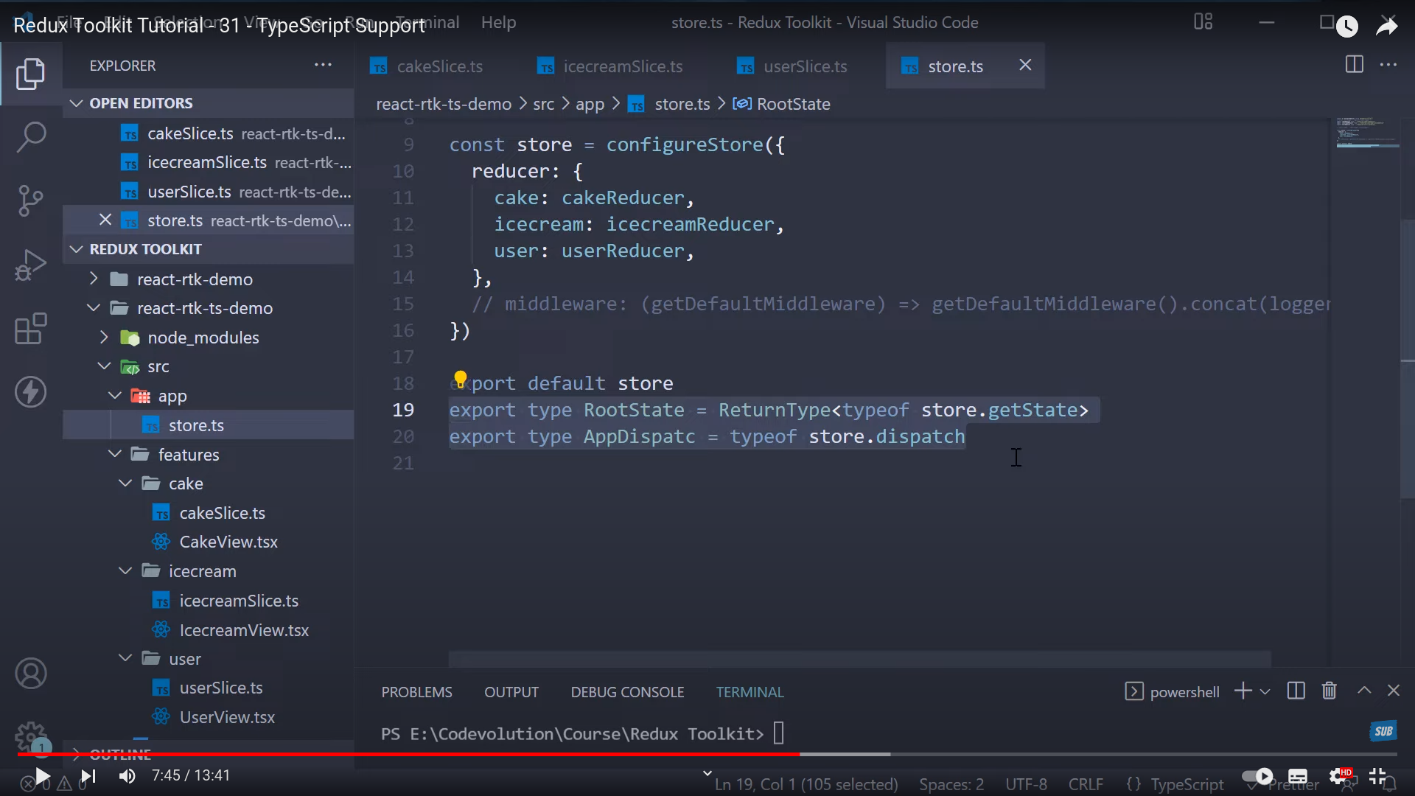
.

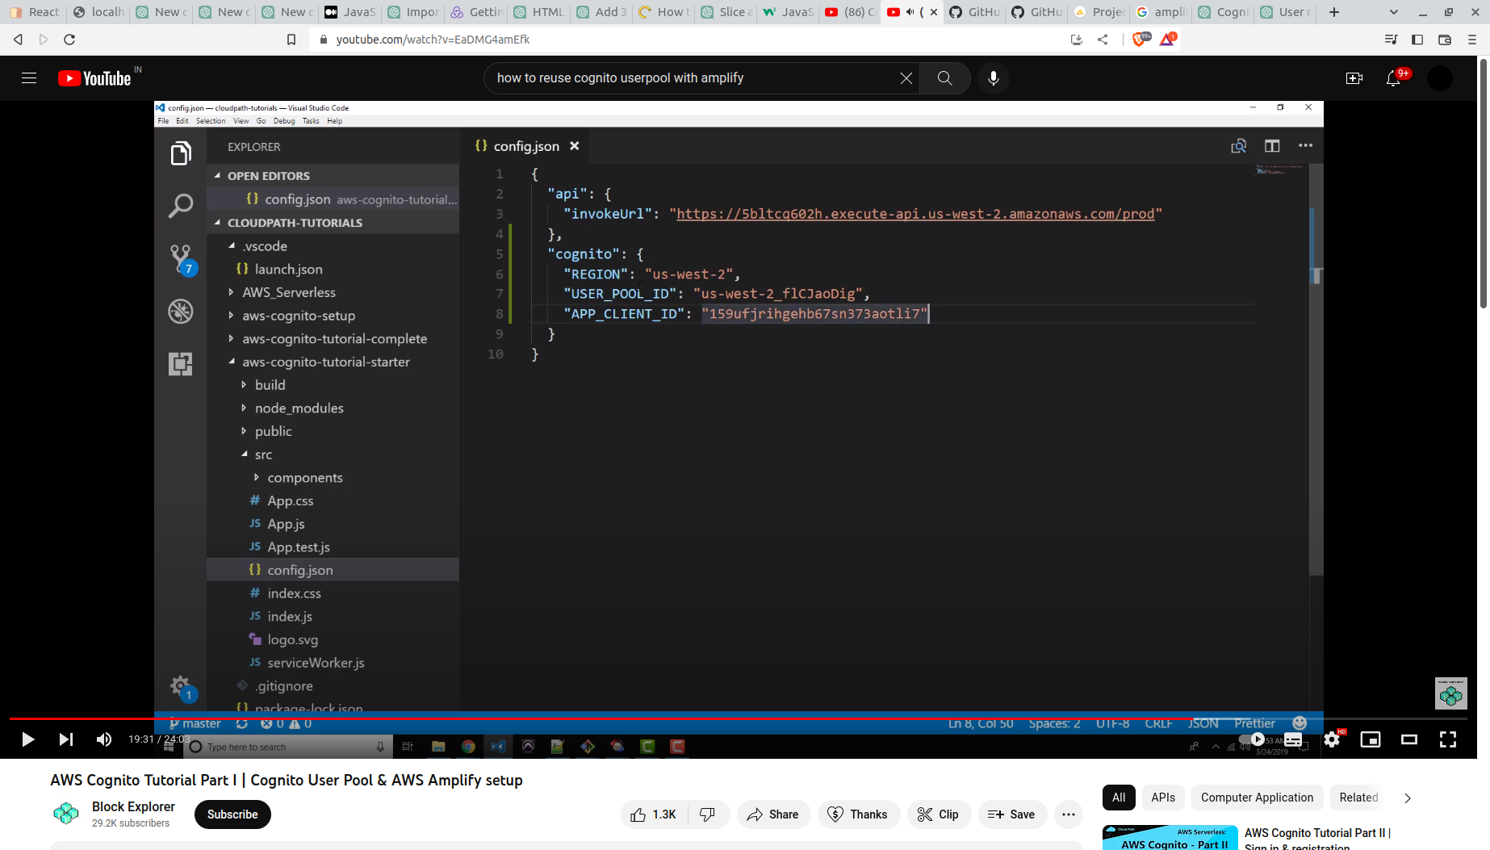
.

// import fs from 'fs';
// export const handler = async(event) => {

// // // const key = event.pathParameters.proxy;
// // const method = event.httpMethod;
// // if(method!='GET'){
// // return { statusCode: 404, body: "Page not found" };
// // }

// // const title=process.env.Title;
// const response = {
// statusCode: 200,
// body: "asndlad",
// headers: {
// 'Content-Type': 'application/json',
// 'Access-Control-Allow-Origin': '*'
// }
// };
// return response;
// };

export const handler = async (event) => {
const data = process.env;
const url = event.path;
const pathSegments = url.split('/').filter(segment => segment !== '');
// const path = event.pathParameters.proxy;
const method = event.httpMethod;
if (method === 'GET' ) {
switch (pathSegments[0]) {
case "Home":
return {
statusCode: 200, headers: {
'Content-Type': 'application/json',
'Access-Control-Allow-Origin': '*'
}, body: data.Home
};
case "Extras":
return {
statusCode: 200, headers: {
'Content-Type': 'application/json',
'Access-Control-Allow-Origin': '*'
}, body: data.Extras
};
case "StartTime":
return {
statusCode: 200, headers: {
'Content-Type': 'application/json',
'Access-Control-Allow-Origin': '*'
}, body: data.StartTime
};
case "CleaningType":
return {
statusCode: 200, headers: {
'Content-Type': 'application/json',
'Access-Control-Allow-Origin': '*'
}, body: data.CleaningType
};

case "CleaningTime":
return {
statusCode: 200, headers: {
'Content-Type': 'application/json',
'Access-Control-Allow-Origin': '*'
}, body: data.CleaningTime
};

default:
return { statusCode: 404, body: "Page not found" };
}
}
else if(method==='PUT' || method==='PUT'){

}
else{
return { statusCode: 404, body: "Page not found" };
}

};

